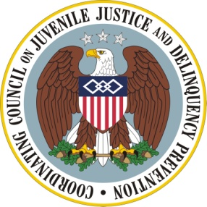

Coordinating Council on Juvenile Justice and Delinquency Prevention
Quarterly Meeting

December 12, 2012

U.S. Department of Justice, Office of Justice Programs
810 Seventh Street, NW, 3rd Floor Conference Center, Washington, DC 20531

10–10:20 a.m. Welcome and Opening Remarks
Mary Lou Leary, Acting Assistant Attorney General, Office of Justice Programs
Tony West, Acting Associate Attorney General, U.S. Department of Justice
Eric H. Holder, Jr., Attorney General, U.S. Department of Justice
Chair, Coordinating Council

10:20–10:30 a.m. Results of the Adverse Childhood Experiences Study
Melodee Hanes, Acting Administrator, Office of Juvenile Justice and Delinquency
Prevention, U.S. Department of Justice
Vincent J. Felitti, MD, Kaiser Permanente Medical Care Program

10:30–11:00 a.m. Defending Childhood: Recommendations
Moderators: Joe Torre, Founder, Joe Torre Safe At Home® Foundation and
Robert Listenbee, Jr., Chief, Juvenile Unit, Defender Association of Philadelphia
Members, Attorney General’s Task Force on Children Exposed to Violence

11:00–11:20 a.m. Discussion of Recommendation Implications with the Task Force
Coordinating Council Members
Task Force Members

11:20 –11:30 a.m. Summary and Meeting Adjournment
Attorney General Eric H. Holder, Jr., Chair

