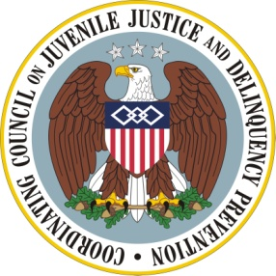

Coordinating Council on Juvenile Justice and Delinquency Prevention
Quarterly Meeting

September 14, 2012

U.S. Department of Justice, Office of Justice Programs
810 Seventh Street NW, 3rd Floor Conference Center, Washington, DC 20531

10–10:05 a.m. Welcome and Opening Remarks
Mary Lou Leary, Acting Assistant Attorney General, Office of Justice Programs,
U.S. Department of Justice

10:05–10:40 a.m. Girls at the Margin: Risk Factors and Needs
Moderator: Lawanda Ravoira, Director, National Girls Institute
Barbara Guthrie, Associate Dean for Academic Affairs and Professor, Yale
School of Nursing
Malika Saar, Executive Director, Human Rights Project for Girls
Terri Yellowhammer, Native Streams Institute, Education Development Center

10:40–11:10 a.m. Girls’ Pathways to Success
Moderator: Lawanda Ravoira, Director, National Girls Institute
Danielle De Land, National Crittenton Foundation
Withelma “T” Ortiz Walker Pettigrew, Member, Board of Directors,
Human Rights Project for Girls
Jeannette Pai-Espinosa, President, National Crittenton Foundation
Francine Sherman, Clinical Professor and Director, Juvenile Rights Advocacy
Project, Boston College Law School

11:10–11:20 a.m. Break

11:20 a.m. –12 p.m. Panelists’ Comments and Discussion of Federal Agency Coordination
Facilitator: Pam Rodriguez, Practitioner Member and President, TASC, Inc.

12–12:25 p.m. Agency Announcements and Updates

12:25–12:30 p.m. Summary and Meeting Adjournment
Mary Lou Leary, Acting Assistant Attorney General

