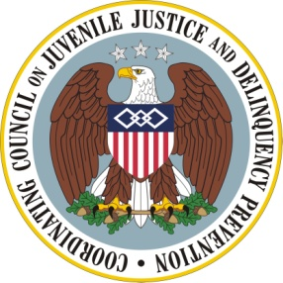

Coordinating Council on Juvenile Justice and Delinquency Prevention
Quarterly Meeting, February 10, 2012

U.S. Department of Justice, Office of Justice Programs
810 Seventh Street NW, Main Conference Room, Washington, DC 20531

10:00–10:10 a.m. Welcome and Opening Remarks
Eric H. Holder, Jr., Attorney General and Coordinating Council Chair

10:10–10:50 a.m. The Pathways to Desistance Study: Implications for Intervention
and Policy
Edward Mulvey, Professor of Psychiatry, University of Pittsburgh School of Medicine
Carol Schubert, Research Program Administrator, University of Pittsburgh School of Medicine

10:50–11:10 a.m. Commentary and Discussion
Randy Muck, Senior Clinical Consultant, Advocates for Youth and Family Behavioral Health Treatment
Terry Zobeck, Associate Director for Research/Data Analysis, Office of National Drug Control Policy

11:10–11:25 a.m. Break

11:25–12:10 p.m. Coordinating Housing Assistance with Educational Opportunities: the HUD- GreatSchools Partnership
Luke Tate, Senior Policy Advisor to the Secretary, U.S. Department of Housing and Urban Development
Maria-Lana Queen, Office of Public and Indian Housing, U.S. Department of Housing and Urban Development
Natanya Levioff, GreatSchools
Iris McLaurin-Southall, D.C. Housing Authority

12:10–12:25 p.m. Agency Announcements and Updates

12:25–12:30 p.m. Summary and Meeting Adjournment
Eric H. Holder, Jr., Chair

