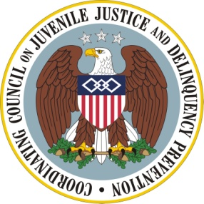
Coordinating Council on Juvenile Justice and Delinquency Prevention

Monday, June 22, 2015

U.S. Department of Justice
Two Constitution Square, 145 N St., NE
Conference Room 1W.1001 First Floor
Washington, DC 20002

10:00 – 10:20 am Opening Remarks & Introductions

Loretta E. Lynch, Attorney General of the United States, and
Chair, Coordinating Council

Robert L. Listenbee, Administrator, Office of Juvenile Justice and
Delinquency Prevention, and Vice Chair, Coordinating Council

Council Member Introductions

10:20 – 12:00 pm Discussion of National and State Ramifications of Closer to Home: An Analysis of the State and Local Impact of the Texas Juvenile Justice Reforms

Michael Thompson, Director, Justice Center, Council of State Governments

Randy Turner, Director, Tarrant County (Texas) Juvenile Services

Susan Burke, Director, Juvenile Justice Services, Utah Commission on Criminal and Juvenile Justice

John Tilley, Representative, Kentucky House of Representatives

Council Member and Speaker Discussion

12:00 – 12:25 pm Council Member Announcements

12:25 – 12:30 pm Meeting Adjournment

Robert L. Listenbee

