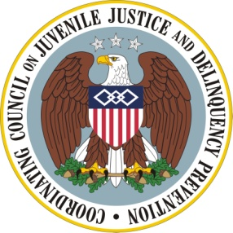
The Agenda

Coordinating Council on Juvenile Justice and Delinquency Prevention
Quarterly Meeting

Wednesday, November 13, 2013

U.S. Department of Justice, Office of Justice Programs
810 Seventh Street, NW, 3rd Floor Conference Center, Washington, DC 20531

10:30-10:45 am Welcome, Opening Remarks, and Introductions

Tony West, Associate Attorney General, U.S. Department of Justice (DOJ)

Robert Listenbee, Administrator, Office of Juvenile Justice and Delinquency Prevention (OJJDP), DOJ, Vice Chair, Coordinating Council

10:45-12:15 pm The Affordable Care Act (ACA): Implications for Vulnerable Adolescents and Young Adults

Wilma Robinson, Deputy Director, Office of Adolescent Health, U.S. Department of Health and Human Services (HHS)

Abigail English, Director, Center for Adolescent Health and the Law

Barbara Edwards, Director, Disabled and Elderly Health Programs Group, Center for Medicaid, CHIP, and Survey & Certification, Centers for Medicare and Medicaid Services, HHS.

Diane Justice, Senior Program Director, National Academy for State Health Policy

Council Member Discussion

12:15-12:25 pm Agency and Practitioner Announcements

12:25-12:30 pm Summary and Meeting Adjournment
Robert Listenbee, Administrator, OJJDP, Council Vice Chair

