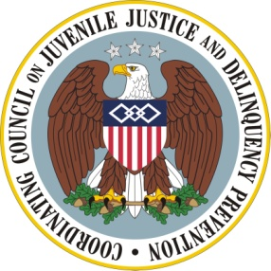

AGENDA

Coordinating Council on Juvenile Justice and Delinquency Prevention
Quarterly Meeting

Friday, July 26, 2013

U.S. Department of Justice, Office of Justice Programs
810 Seventh Street NW, 3rd Floor Conference Center, Washington, DC

10:00-10:15 am Welcome, Opening Remarks, and Introductions

Robert Listenbee, Administrator, Office of Juvenile Justice and Delinquency Prevention, DOJ, Vice Chair, Coordinating Council

Tony West, Associate Attorney General, DOJ

10:15-11:30 am NAS Report “Reforming Juvenile Justice: A Developmental Approach”: Implications for Federal and State Programs, Policy and Practice

Robert Johnson, Director, Division of Adolescent and Young Adult Medicine, Rutgers University – New Jersey Medical School

Edward Mulvey, Director, Law and Psychiatry Program, Western Psychiatric Institute and Clinic, University of Pittsburgh School of Medicine

Gladys Carrion, Commissioner, New York State Office of Children and Family Services

Responder: Clare Anderson, Deputy Commissioner, Administration for Children, Youth and Families, U.S. Department of Health and Human Services

Council Member Discussion

11:30-11:40 am Agency and Practitioner Announcements

11:40-11:45 am Summary and Meeting Adjournment

Robert Listenbee, Council Vice-Chair, Administrator, OJJDP

